**Project Title : Smart Storage Bin**

**Student Names : Kavin A S (RA1911004010008), Rohit Kumar Mohanty (RA1911004010259), Keerthi Appana (RA1911004010523)**

**Project Guide :** **Dr. Sounik Kiran Kumar Dash, Assistant Professor**

**ABSTRACT:**

Fresh foods must be stored, transported, and preserved to maintain their freshness because they are perishable, seasonal, and regional. The Internet of things (IoT) attempts to use the internet to connect various things and objects. The suggested method measures the surrounding environment's temperature, and humidity level because these factors have an impact on food items' nutritional properties. In this project, a system for analyzing the ambient conditions in which the food item is stored is proposed. The rapid development of the Internet of Things motivates the use to apply for the food preservation domain such as maintaining the quality of fruits and vegetables.

BLOCK DIAGRAM

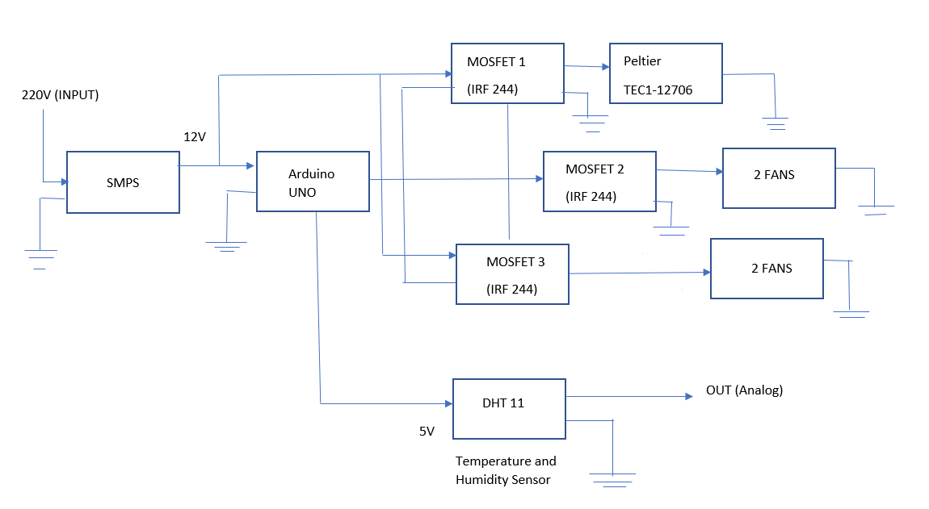

PROTOTYPE

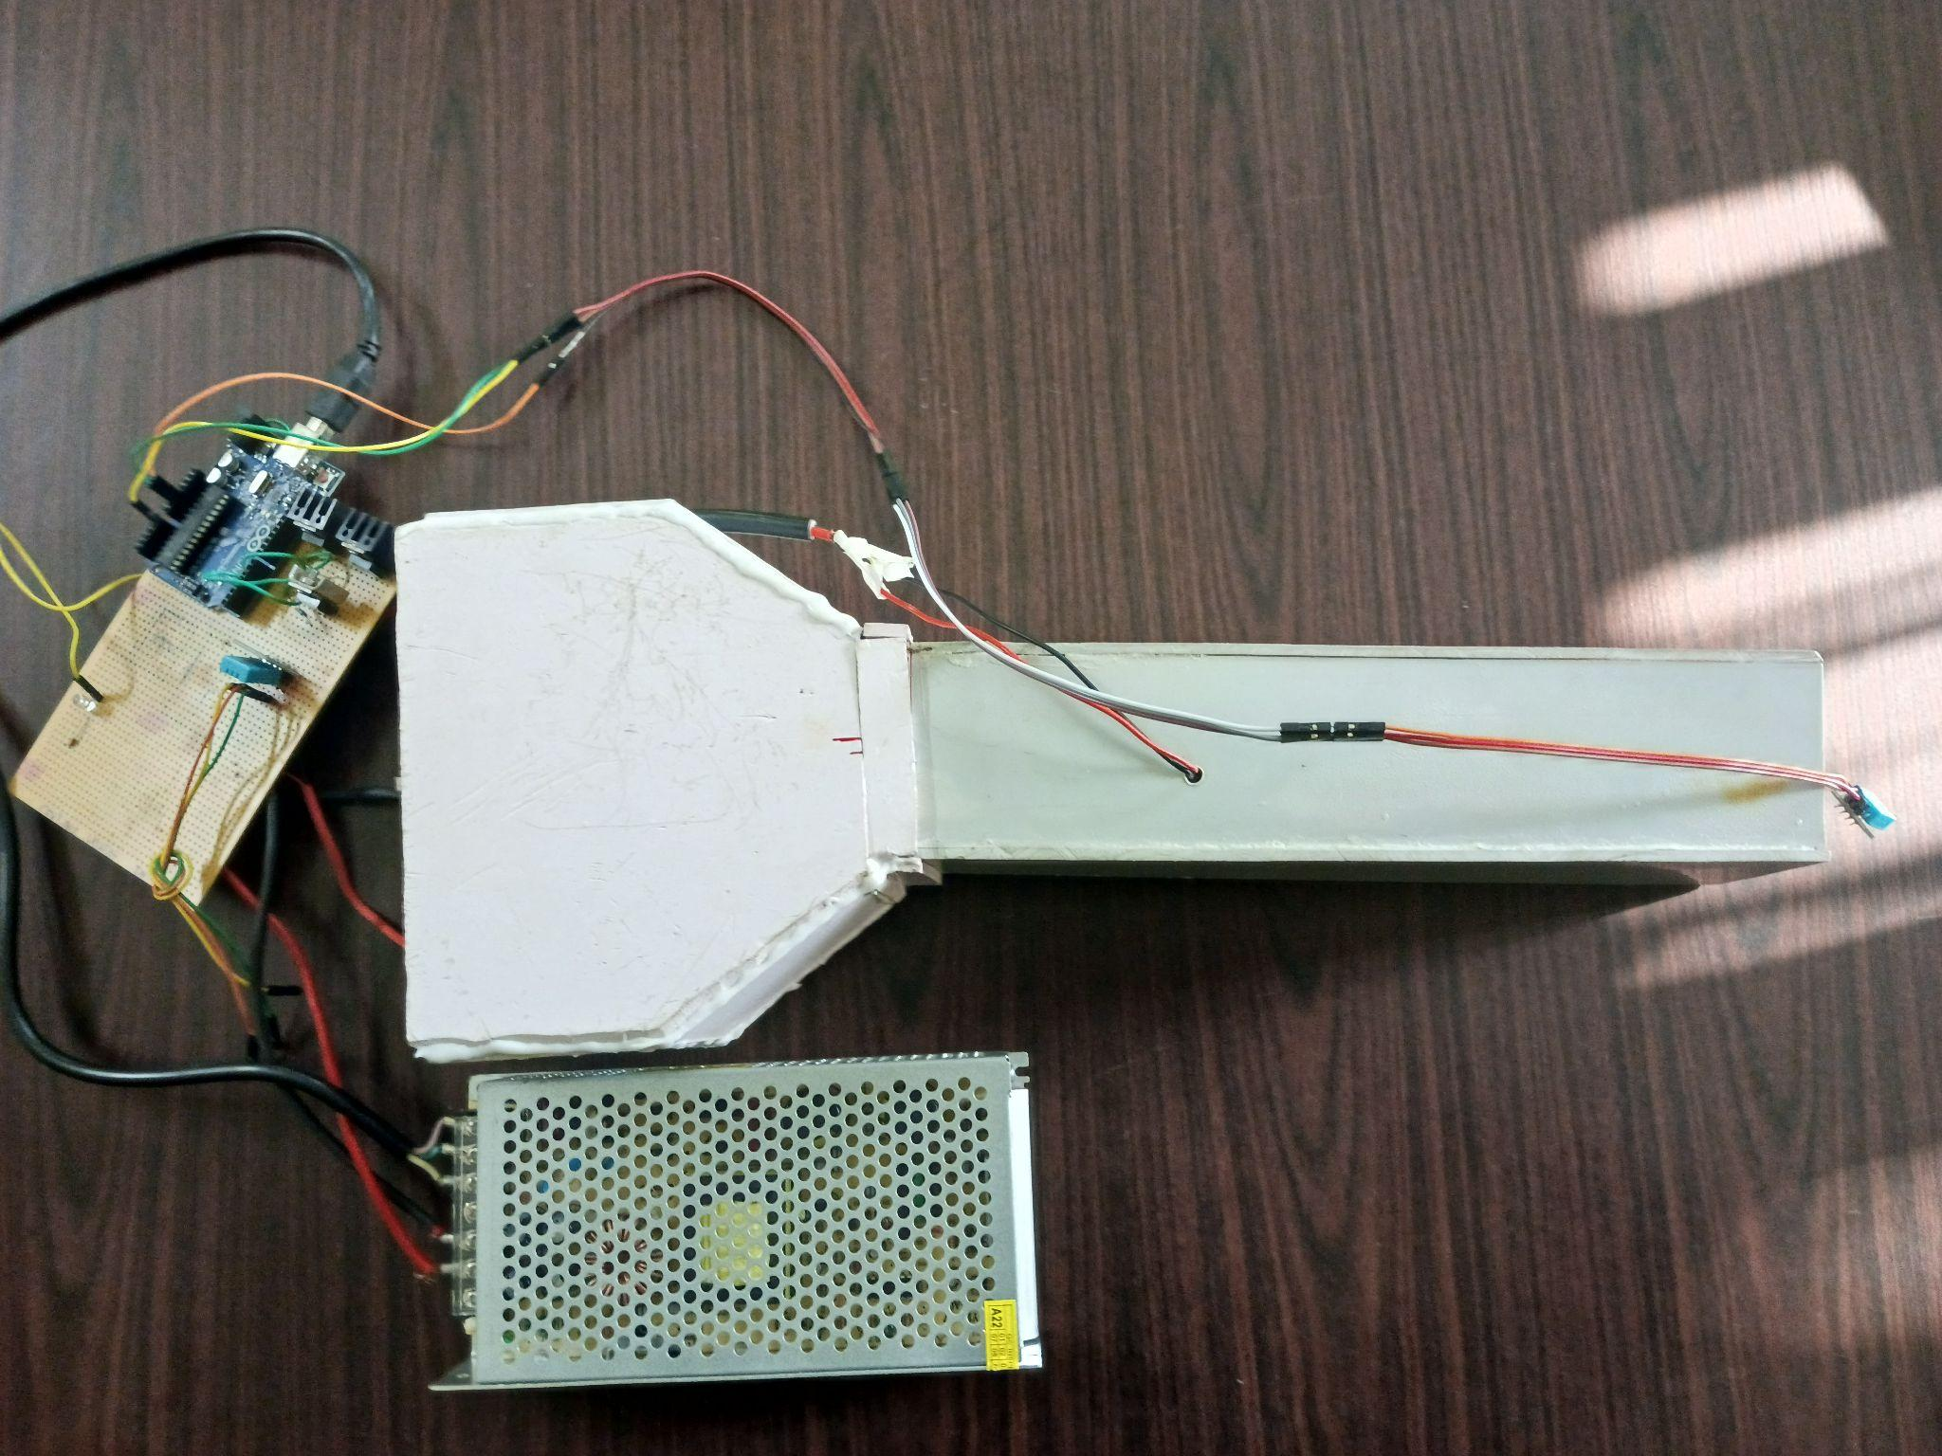

|  |  |
| --- | --- |
| **Objectives** | 1. The primary goal of this project is to reduce the risk of crop destruction due to temperature, humidity, fire, rain and other factors by preserving the fruits and vegetables. 2. Thus, the farm produce that has been kept can be provided as and when needed. |
| **Knowledge acquired in the listed courses** | 1. Electronic Devices-18ECC102J 2. Analog Electronic Circuits- 18ECC201J |
| **Realistic Constraints** | 1. It took a few days to get the peltier properly configured with the heat sink and switched power supply (SMPS). 2. Using an Arduino, it is difficult to make peltier compatible with MOSFET and fan since peltier operates in both hot and cold environments. 3. Controlling the humidity and temperature using peltier and the DHT11 sensor is a challenging task. |
| **Multidisciplinary tasks involved** | 1. Circuit diagram/System Architecture 2. Testing of peltier and other peripherals 3. Assembling all the components of the circuit and then testing it 4. Environmental temperature and humidity monitoring of peltier 5. Detecting temperature and humidity level using DHT11 sensor 6. Making the circuit compatible with a storage crate |
| **Deliverables/ Outcomes** | 1. Environmental elements including the type of storage structure, temperature, pH, moisture, etc. have a significant impact on the natural contamination of the food grains. 2. Hence using peltier by controlling the temperature and humidity of the environment and using DHT11 sensor a smart storage bin is implemented. |